

**Druva Phoenix**

**Plugin Configuration Guide**

Contents

Druva Phoenix Configuration Checklist 2

Supported Collection Types 2

Data Sources 2

Requirements 3

API Access 3

Firewall Ports 3

Setup 3

Server Properties 3

Field Definitions 4

Troubleshooting 5

Test Connection shows failed with no additional messages 5

Data Collection fails with error: HTTPS status code 429 not expected, message limit exceeded 5

429 Too Many Requests 5

Jobs are not collected with scheduled updates - are during backfill 5

Technical Support 6

# Druva Phoenix Configuration Checklist

The following is an overview of the steps to configure Druva Phoenix collections on your Bocada Data Collection Server:

* [Verify API credentials](https://docs.druva.com/Druva_Cloud_Platform/Integration_with_Druva_APIs/Create_and_Manage_API_Credentials) (Client ID and Secret Key). Bocada currently supports the following backup types:
* File Server
* NAS
* VMware
* SQL Server
* Oracle Direct to Cloud
* Oracle Phoenix Backup Store
* Ask Druva Support to upgrade your API requests rate limit from 10k per day to 100k per day. This is not typically needed immediately, but eventually you may encounter this limit.

# Supported Collection Types

The plugin in supports the following collection types from Druva Phoenix:

|  |  |  |
| --- | --- | --- |
| **Collection Type** | **Supported** | **Description** |
| Backup | ✓ | Collects transactional details about backup, defreeze  and restore jobs. Example metrics include, start times, durations, bytes, files, errors etc. |
| In Progress | ✓ | Collects basic information on backup jobs that are running. |

# Data Sources

The plugin relies on the following Druva Phoenix data sources:

* Druva Phoenix REST API

The scope of data collected from Druva Phoenix is limited to what is available to the API Credentials as described in the [Druva API documentation](https://docs.druva.com/Druva_Cloud_Platform/Integration_with_Druva_APIs/Create_and_Manage_API_Credentials).

# Requirements

This section lists requirements that must be met prior to collecting data with the Bocada plugin for Druva Phoenix.

### API Access

Obtain API credentials as described in this document from Druva <https://docs.druva.com/Druva_Cloud_Platform/Integration_with_Druva_APIs/Create_and_Manage_API_Credentials>

Request Druva Support to upgrade your API requests rate limit from 10k per day to 100k per day. This is not typically needed immediately, but eventually you are likely to encounter this limit in the Bocada data collections.

### Firewall Ports

|  |  |  |
| --- | --- | --- |
| **Service** | **Default Port** | **Note** |
| HTTPS | 443 | Outbound from DCS to Phoenix API |

# Setup

### Server Properties

Backup Server Properties determine how the plugin will interface with the Druva Phoenix cloud and are managed through the Backup Servers view.

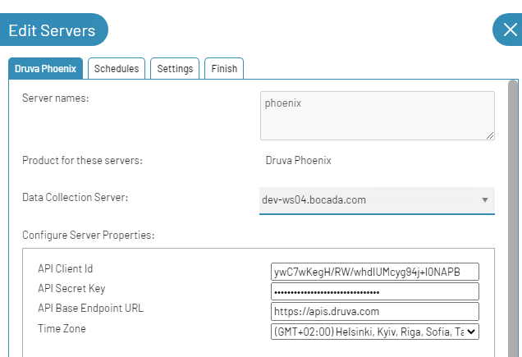

### Field Definitions

#### Server name

Enter a name for the Druva Phoenix SaaS that you wish to see within Bocada. Separate Phoenix Organizations can be separated within Bocada by using descriptive names and the associated API Client ID and Secret key for users with access to specific resources.

#### API Client Id

Enter the Client Id that you should get from Druva Phoenix server during Configuration Checklist stage.

#### API Secret Key

Enter the Secret Key that you should get from Druva Phoenix server during Configuration Checklist stage.

#### API Base Endpoint URL

Enter the Endpoint URL that you should get from the Druva Phoenix API Credentials page. If you need to migrate to a new API server - you need to set an actual “API Base Endpoint URL” property value.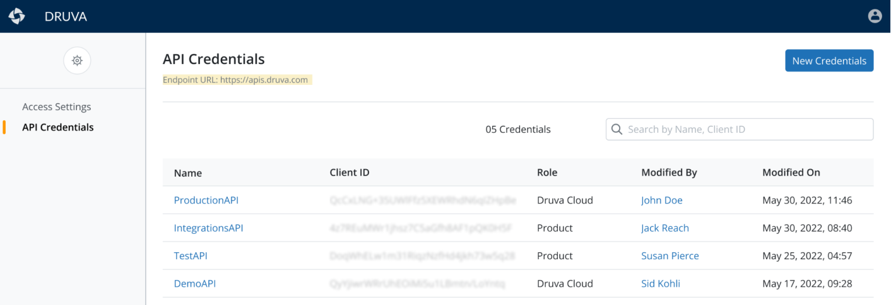

#### Time Zone

Select the time zone where Druva Phoenix server resides. This setting ensures times are displayed consistently in environments that span multiple time zones.

# Troubleshooting

## Test Connection shows failed with no additional messages

Sometimes *Test Connection* in the server properties will show a message failed with no further information. This may be a fault in the *Test Connection* feature, please try running data collection updates to see if they are successful.

## Data Collection fails with error: HTTPS status code 429 not expected, message limit exceeded

This issue is caused by the Druva Phoenix API web site Rate Limiting. From RFC 6585 (https://tools.ietf.org/html/rfc6585)

## ****429 Too Many Requests****

The 429 status code indicates that the user has sent too many requests in a given amount of time ("rate limiting").

The solution is to open a support case with Druva and request that they upgrade your limit from 10k to 100k requests per day. You can reference Druva Case :00158594 for Bocada to help the Druva support team more quickly understand the problem and established solution.

## Jobs are not collected with scheduled updates - are during backfill

Phoenix REST API works by Queued Date as a Start Date, so if in your environment the time range after a job is queued but not started will be bigger than the “Backfill hours” hidden plugin property – this job can be missed with schedules updates, so to prevent it – please increate “Backfill hours” property value:

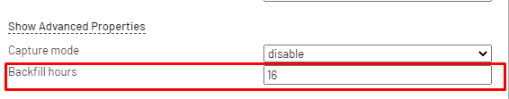

# Technical Support

For technical support, or for a copy of our standard support agreement, please contact us.

**E-mail:** [support@bocada.com](mailto:support@bocada.com)

**Support Portal:** <https://bocada-support.force.com>

**Phone:** +1-425-898-2400